Bamboozle

By Jordan Davies

**Gameplay Overview**

In Bamboozle you will play as a Bunny/Turtle that must reach their home and must avoid certain death by many obstacles. You will hop/crawl avoiding obstacles as you go and try and survive while accumulating points towards your score, the score goes up when the player moves forward, moving backwards will cause you to lose 2 points adding in a penalty and more consequences for poor strategy. Reaching the end of the obstacles means it’s the end of the level.

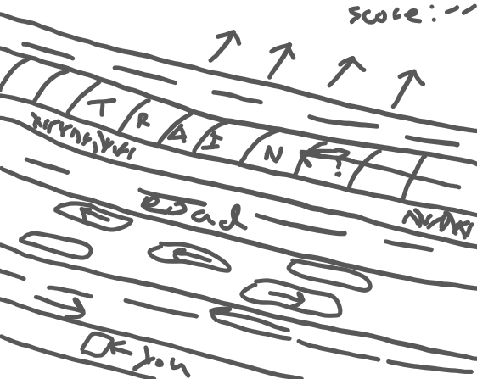

**Characters**

**Bunny**: He is a lost little bunny and only with your guidance can he make it through the dangerous path ahead. He can hop and dodge fast through traffic but cannot swim which means he is forced to hop on the logs.

**Turtle**: He has lost his way from the beach. He can swim which means he is able to swim in the rivers and use the logs, but he is slower to move on the roads and land than the bunny is.

Having 2 characters with different abilities allows some amount of control for how the player wants to play.

Levels

There will be 3 levels, and each will be more difficult than the last, adding more obstacles and new ones. Completing all three levels means you have beaten the game.

Obstacles will consist of:

**Roads**: cars will race across the screen, if the car collides with the player then you lose.

**Rivers**: rivers have logs that float along the screen and the player can catch a ride on these to the next point, missing a log and entering the water means you lose.

**Trains**: are faster than cars and more difficult to get past, getting hit by a train will be devastating. The Player can only rest on the green waysides, they will be often enough to allow the player some respite and let them compose themselves before moving on.